**M3E- Mediterranean Extreme Events Experiment**

Document Version 2: 2025-07-02

**Motivations**

Extreme weather events across the Mediterranean Sea can cause significant damages in the surrounding countries, and notable recent devastating events include the Acqua Alta event in Venice in 2019, Storm Alex in October 2020, Storm Daniel in September 2023, and the widespread flooding in the Emilia-Romagna region of Italy in 2023 and 2024. Following these storms, an important scientific question has been posed: in the future could more accurate forecasts of these types of storms be provided if additional oceanographic/sea surface/air-sea interaction observations were added across the Mediterranean Sea? If realized, this could benefit the countries surrounding the Mediterranean by providing improved awareness and warning for such events. Many of these countries are Member and Co-operating States of ECMWF.

In January/February 2026 there will be a Global Observational Campaign entitled Global Atmospheric River Reconnaissance Campaign (GARRP) whose aim is to investigate whether adding extra observations across the North Pacific and North Atlantic Oceans may increase medium-range weather forecast skill. These observations include dropsondes from aircraft, radiosondes, and drifting buoys with barometers. Under the umbrella of GARRP are the AR Recon campaign across the northern Pacific and the NAWDIC campaign across the North Atlantic and Europe.

With high-impact weather also affecting the Mediterranean, we propose to add sea oceanographic/sea surface/air-sea interactions in areas where such extreme events seem to be impacted by air-sea interactions. We are seeking opportunities to add the Mediterranean Sea as an important part of the GARRP campaigns.

**Mediterranean Sea Target areas**

Two target areas are identified in the Mediterranean Sea for M3E: the Ionian Sea and the Tyrrhenian Sea.

The Ionian Sea is a region that remains relatively under-monitored by surface drifter observations, despite its significant role in regional weather and climate dynamics.

Importantly, the Ionian Sea is among the areas most frequently affected by intense cyclonic activity, including Medicanes (Mediterranean tropical-like cyclones), storms and cyclones, especially during the late summer and autumn months (Fig. 1).

*Fig. 1: Tracks of some Medicanes that occurred in the Mediterranean Basin between 2011 and 2021 (information sourced from Borzì et al. 2024)*

The Tyrrhenian Sea and the Ionian Sea are well-recognized as key areas of high cyclone density persistence in the Mediterranean basin (Fig. 2). This means that these areas are frequently characterized by cyclones and can trigger intense precipitation and severe storms, not only over the sea itself, but these can have impacts also over land areas located hundreds of kilometers away from where the cyclones initially form. In recent years, cyclonic systems developing over the Tyrrhenian Sea, in particular, have been responsible for extreme rainfall events and river flooding in regions far inland.

This is the case of 2023 and 2024 floods in Emilia-Romagna when although no extreme hourly rainfall was recorded, the accumulated rainfall over several days was sufficient to produce extreme flooding: the stationary cyclones over central Italy were responsible for the continuous feeding of the atmospheric column, inducing vertically integrated horizontal water vapor convergence.

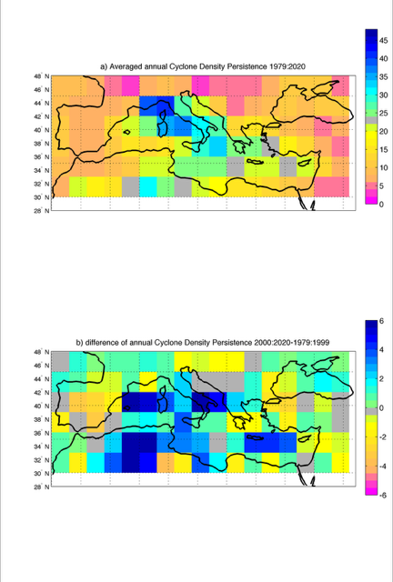



*Fig 2. Maps of average annual cyclone density persistence between 1979 and 2020 (top). Decadal difference [2000:2020 – 1979:1999] of annual Cyclone Density Persistence (bottom). From Scoccimarro et al. 2025.*

Understanding the dynamics and persistence of cyclone activity in the Tyrrhenian and Ionian Seas is therefore crucial for improving forecasts of heavy precipitation, mitigating flood risks, and enhancing the resilience of coastal and inland communities to severe weather events linked to Mediterranean cyclogenesis.

**M3E Objectives**

Main objectives of this experiment in the Mediterranean Sea are:

* Improve the weather forecast of extreme events, including Medicanes, and show the impact on the coastal extreme events
* Understand rapid cyclone development in the Mediterranean Sea and eventually map atmospheric rivers.
* Contribute to the GARRP experiment as Mediterranean Italian task team

**Experiment Partners**

* **OGS** Pierre Marie Poulain, Milena Menna - Coordinator
* **CMCC** Emanuela Clementi, Viviana Piermattei, Enrico Scoccimarro, Paola Mercogliano, Mario Raffa, Angelo Campanale, Paolo Oddo - Co-Coordinator
* **Agenzia Italia Meteo** Carlo Cacciamani, Lina Porciello, Giacomo Davide Pagliaro
* **E-SURFMAR/MF**
* **ECMWF**

**Suggested Periods of M3E**

Two periods have been identified:

* August-September 2025 - precursor experiment: Ionian Sea
* January-February 2026 - together with the GARPP partners: Tyrrhenian Sea – Ionian Sea

**Workplan**

OGS

* In the first experiment in August-September 2025, 7 Drifters can be deployed: 2 will be deployed in the Sicily Channel thanks to a collaboration with the University of Malta and the others will be deployed in the northern Ionian onboard of R/V Laura Bassi
* In the January/February 2026 experiment, several drifters can be deployed as part of the MedShip that will travel from Gibraltar to the West Med and will also have some tracks in the Adriatic Sea and Ionia Sea.

CMCC:

* Several Drifters (SVPB/DWSB, indicatively 12/16) can be acquired and potentially deployed during the MedShip January/February 2026 experiment in the Ionian Sea, as well as in other potential surveys in the Tyrrhenian Sea during 2026.
* CMCC will contribute to the analysis of the impact of such observations in extreme events predictions through numerical modeling for both the atmospheric and ocean components

Agenzia Italia Meteo:

* Make use of the observations in atmospheric limited area modeling and forecasting

**References**

Alfio Marco Borzì, Vittorio Minio, Raphael De Plaen, Thomas Lecocq, Flavio Cannavò, Giuseppe Ciraolo, Sebastiano D'Amico, Carlo Lo Re, Carmelo Monaco, Marco Picone, Giovanni Scardino, Giovanni Scicchitano, Andrea Cannat (2024). Long-term analysis of microseism during extreme weather events: Medicanes and common storms in the Mediterranean Sea, Science of The Total Environment, Volume 915, <https://doi.org/10.1016/j.scitotenv.2024.169989>.

Scoccimarro et al., 2025. The Emilia-Romagna floods: a cul-de-sac in a changing climate.

Submitted to Nature-Commsenv.